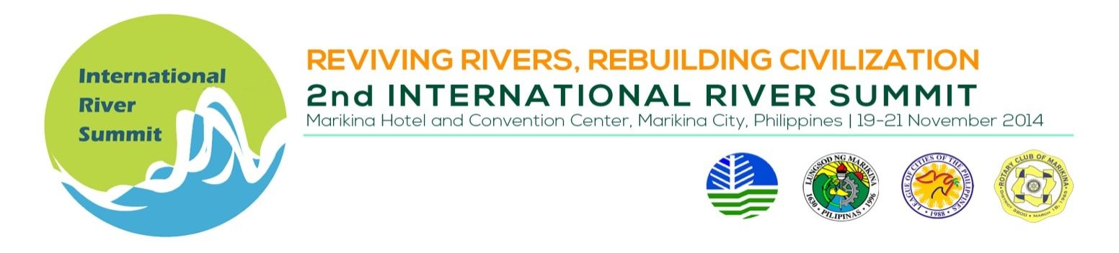
INDICATIVE PROGAMME

Thematic Session 4 : Corporate Social Responsibility

Venue : Session Rm No. 3, 2nd flr. Convention Center

Date/Time : November 19, 2014, Wednesday, 1:30 pm to 5:00 pm

Session Chair : Mr. Jeric T. Sevilla, Jr.
Head, Corporate Communications, Manila Water Company, Inc.

TIME | TOPIC | SPEAKER
 | SESSION INTRODUCTION | Mr. Jeric T. Sevilla, Head, Corporate Communications, Manila Water Company, Inc.
 | Working with the Communities: The Case of Petron Foundation | Chairmaine V. Canillas  Asst. Vice President for Corporate Affairs, Petron Corporation and General Manager, Petron Foundation, Inc.
 | Development of Sustainable Communities | Ms. Anna Maria Gonzales,  Sustainable Planning Manager  Central Land Acquisition Unit, Ayala Land, Inc.
 | BREAK
 | Private Sector Engagement in Integrated River Basin Management – Seeking Meaningful Collaboration Not Conflict | Ms. Melanie Ryan, International Programs Manager, International River Foundation, Australia
 | LGU- Corporate Partnership: Corporate Social Responsibility in San Juan River, Mandaluyong City | Hon. Charisse Marie A. Abalos and Hon. Cherry Lynn Pablo-Santos, City Councilors, Mandaluyong City, Philippines
 | Toka Toka para sa Malinis na Ilog (Assigning responsibilities for a clean river) | Mr. Fernando Busuego III  Branding and Market Research Department Head, Manila Water Company, Inc.

